**Thermal Analysis**

**7.2.1 Introduction**

To conduct a preliminary analysis of the thermal environment in a low-orbit for the SOS-CUBE, a single-node lumped mass analysis is performed for a sun-synchronous orbit. The operational range of temperatures for a CubeSat is between 273K and 373K. This analysis aims to determine the equilibrium temperature of the SOS-CUBE in both, hot case and cold case, and verify whether it falls within the acceptable range. This study was conducted with the help of the article “Preliminary Thermal Analysis of Small Satellites” by Casper Versteeg and David L. Cotton from The University of Georgia.

**7.2.2 Methodology**

The factors affecting the thermal environment are solar radiation, infrared rays (IR), and albedo. IR and albedo heating are influenced by the β angle, which is the angle between the sun-vector and the orbital plane. The beta angle (β) varies over the course of a year and has a theoretical range of ± 90 degrees. For β = ± 90 degrees, the satellite will constantly be exposed to sunlight. As β decreases the the orbit plane and orbital plane and the horizon of the Earth will intersect, at which point the satellite will be in eclipse. This angle is called the critical beta angle (β*) and it is defined by Equation (1).

(1)

β* = sin-1(R/R+h)

* R is the radius of the Earth (≈ 6873km)
* h is the altitude in meters

The albedo factor (a) is defined by Equation (2).

a = {0.14, β < 30 degrees

(2)

{0.19, β > 30 degrees

The IR flux (q_IR) is given by Equation (3).

q_IR= {228 Wm^-2, β < 30 degrees

(3)

{218 Wm^-2, β > 30 degrees

For considering the heat during eclipse, a function, namely the s factor, is added which is given by Equation (4).

(4)

s(t) = {1, τ/2 (1 – f) > t > τ/2 (1 + f)

{0, else

* τ is orbital period in seconds
* f is the eclipse fraction given by Equation (5).

f = {1/180 cos-1(sqrt(h^2 + 2Rh)/(R+h)cos(β), |β| < β*

{0, |β| > β*

* t is the time in seconds

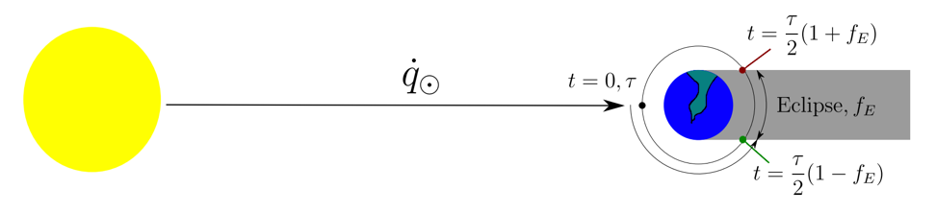

Figure : Determining s factor

The equilibrium temperature of the satellite can be determined by balancing the heat absorbed by satellite, Q_in, defined by Equation (5), and the heat emitted by the satellite, Q_out, defined by Equation (6).

Q_in = Q_ir + Q_sun + Q_albedo + Q_generated

(5)

Q_in = q_IR*A_IR + (1+a)*s*S*A_sun*α + Q_generated

* A_IR is the area exposed to IR.
* Sis the solar constant, 1361 Wm^-2.
* A_sun is the area exposed to sun.
* α is the absorptivity of the satellite.
* Q_generated us the heat generated by the satellite.

(6)

Q_out = AσεT^4

* A is the area emitting heat.
* σ is the Stefan-Boltzmann constant (5.670374419 × 10−8 Wm^-2).
* ε is the emissivity.
* T is the temperature.

For the SOS-CUBE, the following parameters are assumed:

* α = 0.2
* h = 500000 m
* Area exposed to sun is 0.03 m^2
* Area facing the earth is 0.03 m^2
* Power generated by the satellite is 10W

Moreover, the following parameters are derived:

* ε = 0.74
* β* = 68.8 degrees

**7.2.3 Hot Case and Cold Case**

In the hot case, the satellite will be fully exposed to the sun. For finding the equilibrium temperature in the hot case, β will be assumed to be 90 degrees and the s factor will be 1. By balancing Equation (5) and Equation (6), the equilibrium temperature was found to be 360.49K (≈ 87 degrees Celsius).



Figure : Hot case

In the cold case, the satellite will be fully in eclipse. In this case, β* will be used and the s factor will be 0. By balancing the equations (5) and (6), the equilibrium temperature was found to be 309.43K (≈ 36 degrees Celsius).



Figure : Cold case

Both equilibrium temperatures fall within the operational range of temperatures for a CubeSat. However, the temperatures are on the higher side. To improve this, the absorptivity of the satellite can be decreased and other methods, such as implementing MLI techniques and using PCMs in the design, can be added.